Easy Counting Practice Roger Pfister
See the YouTube video 015 use the link on the aaBridge Welcome page.
What does - Counting the Hand - mean ?
Counting the hand, which is mostly discussed when talking about defense, normally covers two different things. Firstly, working out the distribution of cards in suits that declarer was originally dealt. This is the form of "counting the hand" that this document concentrates on.
Secondly, you can also count both declarer's and partner's high card points as they bid and as the cards are played. By tying this up with the bidding, you can end up with a clear idea of who must have which high cards remaining in their hand. I suggest during this practice you put off doing this second type of counting, until you have the first type, well in hand.
Benefit
The core benefit of "counting the hand" is to get to a point during the play when you know exactly what declarer has left, shape wise, in their hand.
The way to do that is to first work towards a more stable target and work out ...
declarer's ORIGINAL distribution.
Once you know what they started with and of course you know what they have played you know what they have left.
While doing all that may sound daunting it won't seem so daunting as you build up the needed skills.
High Card Points
As suggested above, it is normal to assign hcp to bids as they are made. I recommend that you still do this even though you are not expected to use that information when you first start this counting practice. It is a great habit to get into.
Build your skill in stages
There are five stages that aaBridge can take you through on this skills ladder.
- Learn the common hand distributions. This is covered in the document
Memorize Suit Distributions.doc
the idea is to get to a point such that if someone says to you 431 you just know that the missing number is 5, and this happens without you doing any "sums". In the same way as you would know the answer when someone asks you, what is 7 x 8 ?
- Practice and test your knowledge using the aaBridge feature
Learn the Suit Distributions (training mode)
- Practice and text your knowledge using the aaBridge feature
Learn the Suit Distributions (Exam mode)
the above two are genuinely different stages of learning.
The Memorise Suit Distributions doc and the YouTube video cover both.
- Learn to work out Declarer's original distribution.
This is the stage covered by this document it uses the
Easy Counting Hands RHO/LHO supplied in Books-L
Try not to get TOO involved in the play - focus on counting the hand.
- Practice counting including the high card points and follow the play. You can use the RHO / LHO hands or the Hondo mentoring hands or your own downloaded. The Hondo mentoring hands are good because you know the bidding system that Hondo's students play i.e. 2/1. See the document
Defend like an Expert
After that, all you have two do, is to start to use the skills at a table for real. ☺

Where and How to Practice
Open aaBridge and go to the menubar and then click on
Books-L > 100 plus hands for counting practice - RHO
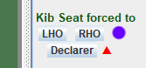
in the right hand column, click on the RHO button (purple dot). Once you have done that the red triangle will show.
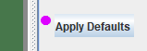
The triangle is to remind you (when you have finished your counting practice) to click the Apply Defaults button (real pink dot). This will reset the aaBridge display back to normal.
The RHO button also rotates the RHO player so that she is in the 'South' zone. As all the supplied hands marked 'RHO' already have the RHO player sitting in the South seat you will not notice this. This 'auto rotation' feature does mean that you can use the RHO button to easily practice with ANY set of hands.
If you get lost (and sometimes you will) you have two approaches:
- Click on the lead bump in the navbar and start again. Remind yourself of the bidding and try to, once again, follow the play and "get the count".
- Quit this hand. There are plenty more.
You are doing this is an exercise. Like using weights in a gym. The idea is to use your time effectively. So if a particular hand that you are trying to count is not working for you give it up and moved to the next one.

Your Opponents
You and your opps tend to be good to expert players who are for the most part pick-up partnerships. For that reason they generally play 2/1 with standard bidding and signals and can be aggressive bidders. The hands are in random order, so do not assume that successive deals have any players in common.
Good luck in your practice

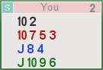
Example A
The hand was taken from real play.
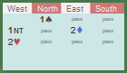
Sitting South you get this very dull hand.
The bidding, partner opens 1♠ (13 hcp, 5 spades) . Fourth in hand (West) protects with a bid of 1NT (13 hcp) and East (2♦) transfers to hearts, (assume 5♥s).
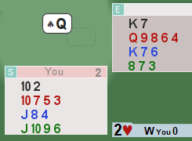
Partner leads the ♠Q and you see.
Your thinking ... Spades ♠ (clockwise from East) 2245 or possibly 2236.
Hearts ♥ 5422 or 5431 5413.
As good approach is to pick the most likely, the most reasonable distribution and go with that until evidence shows otherwise.
♠Q ♠K ♠2 ♠3
♥4 ♥3 ♥A ♥J
♥2 ♥K ♥6 ♥5
♠J ♠7 ♠2 ♠A
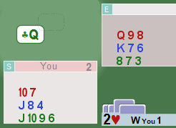
Declarer now wins in dummy with the ♠K. Leads a to heart to her ♥A (and partners ♥J) then leads the ♥2 from hand partner playing ♥K. Partner now leads the ♠J to declarers Ace.
Declarer then leads the ♣Q.
Everything is going pretty much as expected. We now know that declarer started with only 2 hearts. Our assumption that partner with 6 spades would have competed more is reasonable. So were still looking at declarer with the shape of 42??.
Partner plays the ♣A on declarer is Queen and returns the ♠9 which dummy ruffs with the ♥8 and you over ruff with the ♥10 declarer playing the ♠4.
♣Q ♣A ♣3 ♣6
♠9 ♥8 ♥10 ♠4
♣9 ♣K ♦3
You return the ♣9 to declarer's ♣K, partner discarding the ♦3.
Now we have it – Partner started with only one club (the ♣A). So the clubs started (from East clockwise) 34?1 So declarer started with 5.
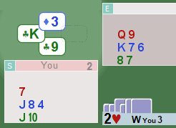
Now we know declarer started with 5 clubs we know their original shape was 42?5. Filling in the missing number gives 4235.


As our goal of this exercise is to get the count of declarer's hand, so we stop here and click the bump and the button to reveal declarer's hand.

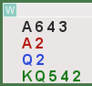
This is a great example of a realistic, at the table, situation. You can't be sure what's happening until the middle of the play and even then some of your numbers will be based on assumptions. Here we are assuming that partner, with opening hand and six spades would compete to the two-level. When she does not complete the to the two-level we take her for only having five spades.

<continued on next page>

Example B
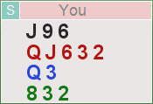
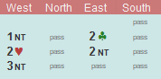
You are South, get this hand,
and the bidding goes.
This hand was taken from real play.

You would normally be revealing the bidding (to yourself) bid by bid, so your thoughts should go something like this.
South (you), pass 6 hcp with a hand shape 3523 (always good to say your hand shape to yourself)
West 1 NT 15-17 you assume 16 hcp (mid way 15-17)
East 2 ♣ 8+ assume at least one 4 card major (as no alert)
West 2 ♥ 4 hearts (ignore the 5 card possibility)
East 2 NT 4 spades
West 3NT and all pass
Partner now leads the 5♣ and you see
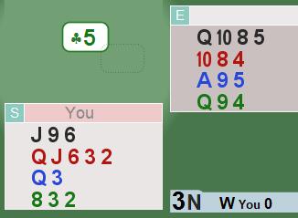
Kk lkjkklkj
HINT
When dummy goes down SAY the shape to yourself 4333

Unusually, before another card is played, it is now possible to work out EXACTLY what partner (North) has in her hand.
Have a go yourself before I give the line of thinking
One good starting point is to take the suits in order. Starting with trumps or with the suit partner led. Both are good approaches but in this case because of the Stayman bid we will start with Hearts. We already know West (declarer) has 4 ♥s this means that (starting with East and going clockwise) we know that the suit is 354? So the ? for partner's heart length has to a singleton.
In spades we know it's (clockwise from East) 43?? We also know that the ? for West is not going to be 4, as West has denied having four spades and promised at least 2 (the NT bid) so West has either 2 or 3 spades. This means the layout in spades is either 4324 or 4333. So partner has either 3 or 4 spades giving the possible hand shapes of 41?? or 31??
At first sight it might look as if this is where we have to stop. We know that partner has either 8 or 9 cards in the minors – the end. But there is something we have missed. Partner led the 5♣ AND you can see ALL the clubs lower than the five. This means that partner has almost certainly led the fourth highest from a 4 card suit. And that means that she must also be holding ONLY 4 diamonds. (Why would partner lead against no-trumps from a 4 card suit if she has a 5 card suit?).
So partner started with 8 cards in the minors and so has to have 4 (not 3) spades.
So unusually we have first worked out partners shape 4144 but doing so means that we will automatically know declarer shape 2443.
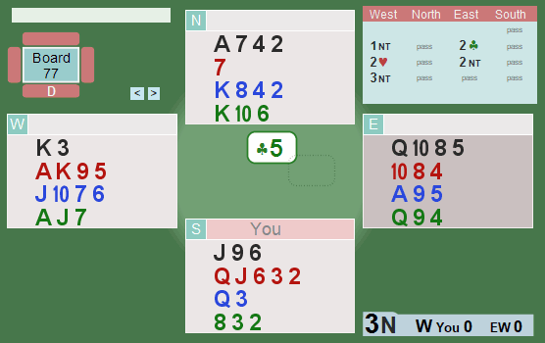
If you are following the rules of this practice that is where it ends. As soon as you think you know the declarer's hand shape
Click the Show button and click the Lead bump and if you got it right, pat yourself on the back try to see what went wrong if you didn't. Then onto the next problem.
Enjoy your counting.
<end document>

